IB Business Management HL IA

Business Research Project

Your business research project will be about a real and contemporary issue or problem facing a particular organization, using one of the four conceptual lenses–ethics, sustainability, creativity, and change. (The issue or problem can be industry-wide, but focus on one organization.)
IB Business Management Guide
University of Manchester’s premier Academic Phrasebank
ThinkIB DP Business Management IA webpage
Purdue OWL’s online APA citation generator and guide
Also consulted: Kognity IA modules

Example D from IB (24/25) and Examiner’s Comments → NOTE that this example ONLY missed points on Criterion F: Structure because it has no subsections in pp. 5-11 of the “Research and Analysis” section, which covers the bulk of the main body.

Example E from IB (20/25) and Examiner’s Comments → NOTE this example mostly missed points for Criterion A: Integration of a Key Concept. According to the examiner, “The focus on economic sustainability means that other aspects of sustainability are missed (and yet Uber was a very good context to consider social and environmental aspects). Knowledge and understanding of the concept is present but partial: the internal assessment (IA) is very robust about financial sustainability, which is analysed here (and could justify A3), but limited on other aspects (which is equally important but ignored), so A2 is the best fit [out of 5 points possible].”

IA Requirements from the IB Business Management Guide

Word Count | Produce a business research project that does not exceed 1,800 words
Business issue or problem | “Select a real and contemporary business issue or problem that relates to any part of the syllabus” (IA Guide, p. 5)  (Human Resource Management, Finance and accounts, Marketing, Operations management)
Single business focus | “Refer directly to a single business organization, but you may consider industry-wide issues that impact on that organization” (IA Guide, p. 5)  (More than one student may choose the same organization, but projects must reflect your own individual research, interpretation and analysis.)
Research Question  [use as title on title page] | “Provide a research question that could be either forward-looking or backward-looking” (IA Guide, p. 5)  (This means you could research and write about either future decisions/effects or a recent decision and its ongoing effects within past 3 years.)  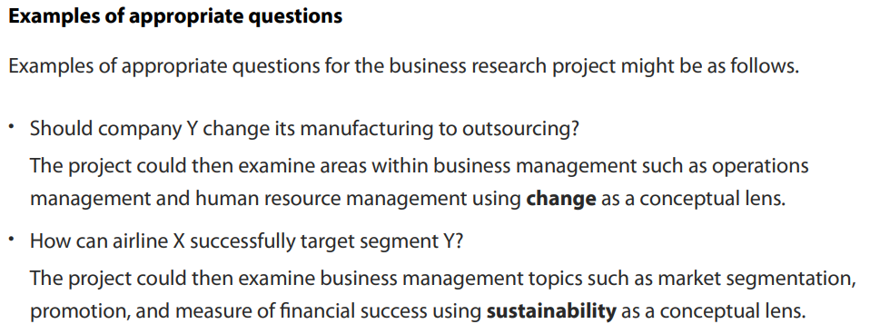 (IB Guide)  **Keep in mind that you will need to use 2 to 4 business management tools and/or theories to analyze and evaluate the issue or problem in your research project. Identifying the tools and theories you can and want to apply will help you decide on your research question, as it relates to the tools and theories in connection with part of the syllabus and your chosen key concept (below).**
Key concept  (Criterion A: 5 marks)  [include key concept on title page] | Your business project must use only one of the four key concepts–change, creativity, ethics or sustainability–as a lens through which to analyze your IA topic.  This key concept may or may not be stated in the research question; however, it must be clearly indicated on the title page which key concept was used. Five marks are available for the identification and use of a relevant key concept; for these marks to be awarded, students must make explicit the conceptual lens they are applying to their work.  From ThinkIB slide deck (ThinkIB):  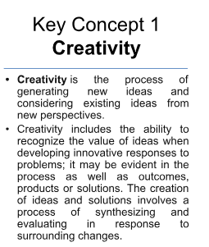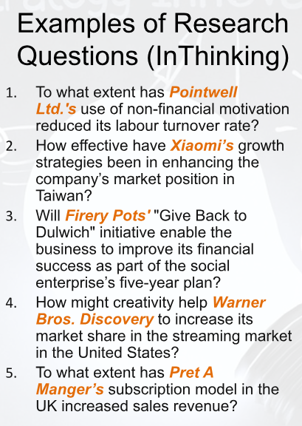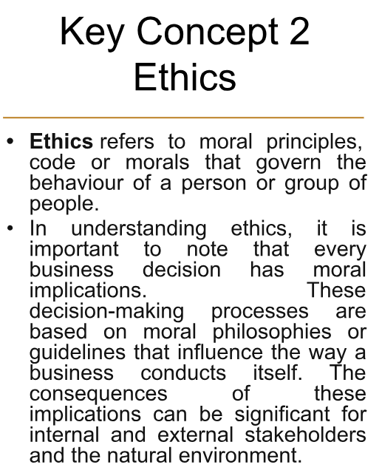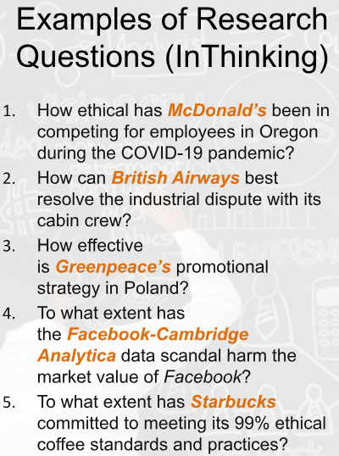  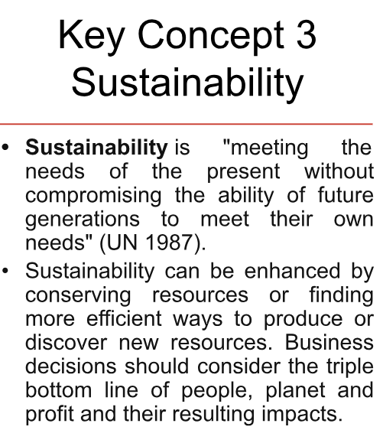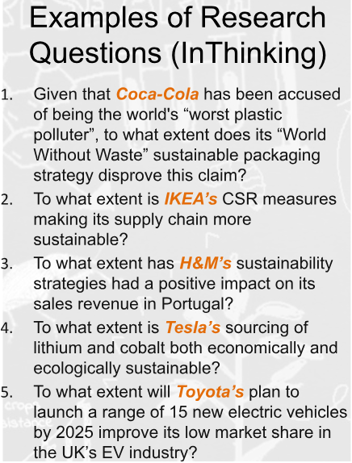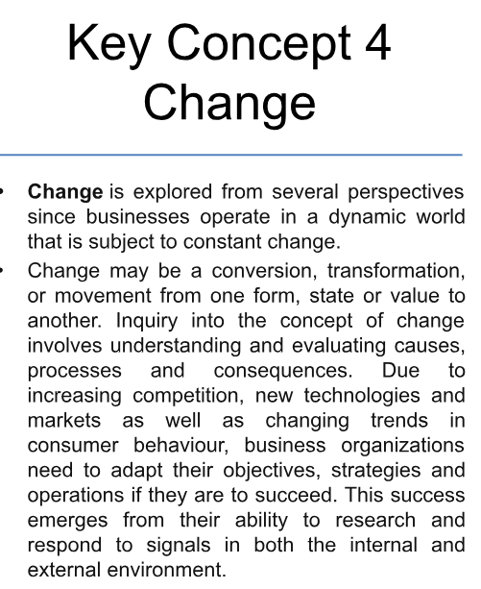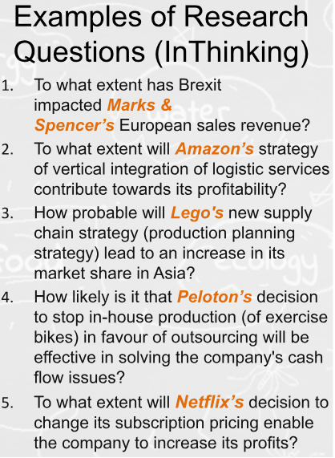
Supporting Documents  (Criterion B: 5 marks) | Attach three to five supporting documents from which the majority of the information for the project has been obtained  (See Research Sources below for more guidance on what these Supporting Documents may comprise.)  From IB guide:  “The selection of supporting documents is very important. To achieve the highest levels of each assessment criterion, it is strongly recommended that the supporting documents present a range of ideas and views. For example, the selection of three to five documents published by a single company, or three to five surveys of similar populations, would not provide balance or objectivity.”  → see suitability, breadth, and depth of sources below!  “A maximum of one of the supporting documents may be a transcript of video or audio material. The transcript must provide the essential points of the video or audio file used for the purposes of the project. Only video or audio material published by a reliable organization should be used (such as the business organization itself, an organization commissioned by the business or an NGO). Particular attention needs to be paid to referencing the original video or audio file so that this may be traced.”  “Students must select three to five of their own supporting documents, which must not be provided to the student by the teacher. Providing supporting documents with many pages is highly discouraged and hence it is recommended that no one supporting document should exceed the equivalent of five A4 pages.  “Students must highlight the parts of each supporting document that relate directly to their project. Any highlighted parts of supporting documents that are not in the language for which the student is registered must be translated.  “Students should label each supporting document clearly, such as “Supporting document 1,” “Supporting document 2,” and so on. This will help with referencing in the project. These should be located at the appropriate section at the end of the document.  “It is expected that students will include in-text citations/references of the supporting documents and a bibliography, which should be formatted in an appropriate way.”  Any additional sources such as textbooks and class notes must be referenced but will not be accepted as supporting documents.
Research sources | Base research on primary and/or secondary research, selected for suitability, depth and breadth.  In general, though not mandatory, a project based mostly upon primary research should have a forward-looking research question and projects based mostly on secondary research should have a backward-looking research question.  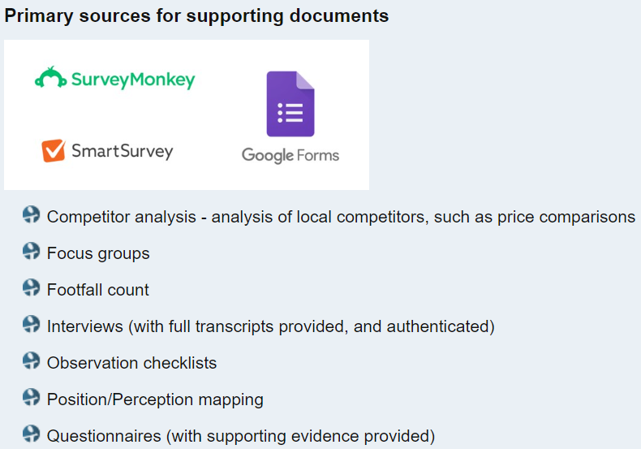(ThinkIB)  IB guide: Primary sources provide first-hand information or direct evidence for the research. Examples of primary sources include:  • face-to-face and online surveys/questionnaires; students should include a blank copy of the questionnaire and a tally/summary of responses  • face-to-face and online interviews; students should include a copy of the interview questions and summary of the responses  • focus group discussions; students should include a copy of the focus group questions and summary of the findings.  Documentation for primary data collection must be included in your “Supporting Documents” appendices. Documentation includes details and instruments for collecting data and the data collected.  What do suitability, breadth, and depth mean for your primary sources?  For primary sources, suitability would mean you have documented and collected relevant data in an acceptable business research form, such as those listed above. Breadth means you either engage in broad sampling for your data (number of surveys or questionnaires, length and variety of observations), or use primary data to engage a range of perspectives or perspective(s) different from those in your other sources. Depth means you designed your primary research to yield significant results and thoughtfully consider the connections or implications.  (ThinkIB)  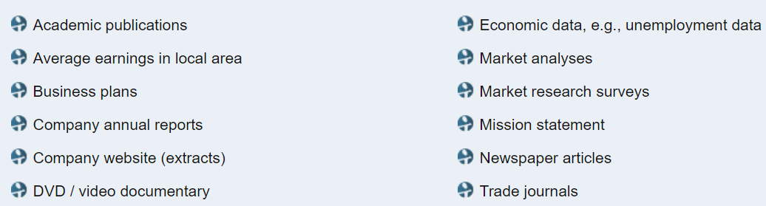  ***Each of the supporting documents must be dated and not over three years old since the submission date to the IB = 20th April 2022***  IB guide: Secondary sources provide second-hand information or already existing data for the research. Examples of secondary sources include:  • articles from the respected local, national or international press  • business accounts  • business plans  • extracts from company websites  • transcripts of a relevant audio-visual file  • financial reports  • government and other statistics  • academic and trade journal publications  • market research surveys  • mission statements.  What do suitability, breadth, and depth mean for your secondary sources?  For secondary sources, suitability means you have found reliable business research sources with relevant information that have been published since April 20, 2021 (Highlight the relevant information when you include the source in the “Supporting Documents” appendices. Breadth means your sources represent more than one perspective or a variety of considerations related to the issue or problem the company faces. Depth means the source provides enough information for you to breakdown in analysis and draw significant conclusions from.
Bibliography/  Works Cited | Fully reference all supporting documents and additional sources and include them all in a bibliography.  Any additional sources such as textbooks and class notes must be referenced but will not be accepted as supporting documents.  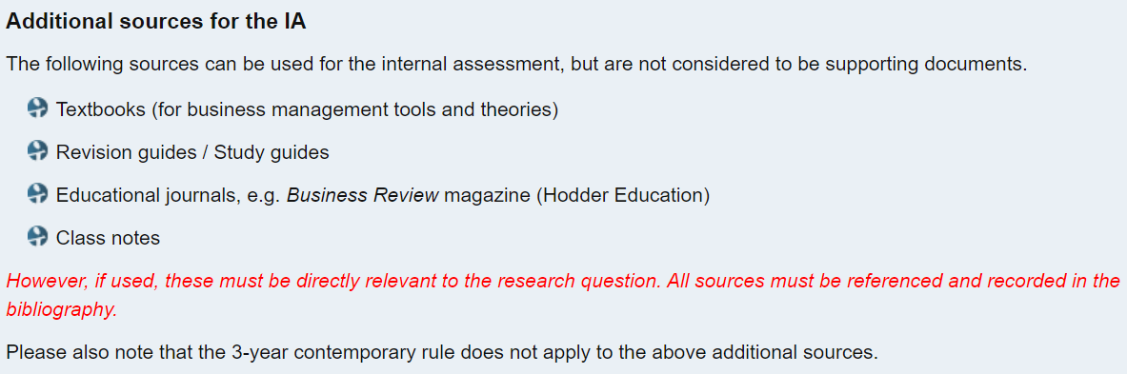  (ThinkIB)  Purdue OWL citation generator for APA

IB Grading Criteria

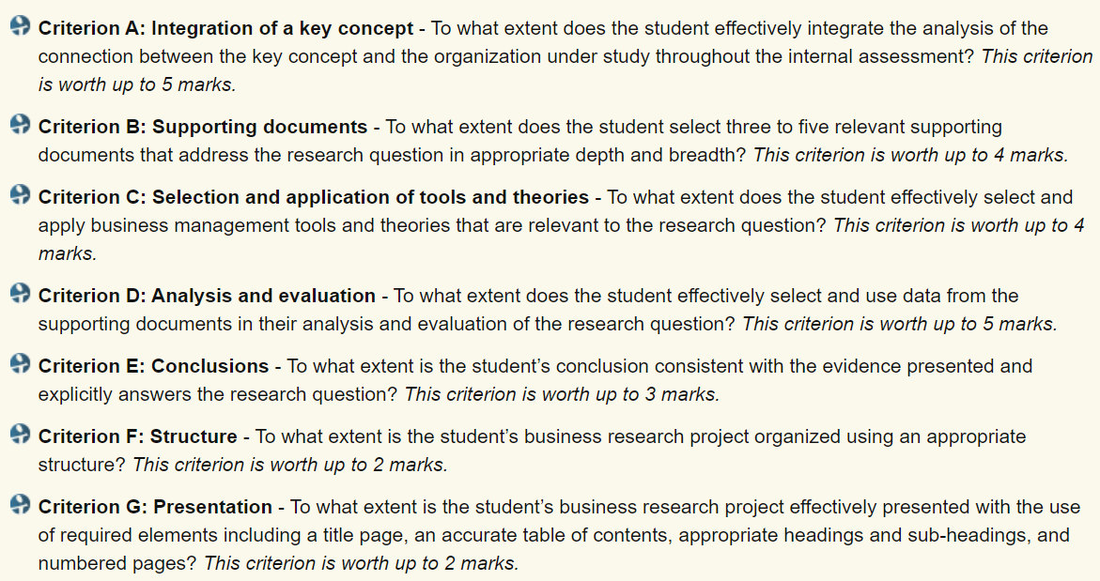

Research Project Structure (Criterion F: 2 marks) & Presentation (Criterion G: 2 marks)

The business research project is intended to be a structured piece of well-organized writing that effectively presents findings and conclusions. There are many different ways that a student might approach the project, but students should ensure that the submitted business research project evidences the following elements.
Check out University of Manchester’s premier Academic Phrasebank for formal academic phrases that ensure your writing is clear and compelling!

- Title page
Crit. A, F
  - Title is the Research Question
  - Key Concept is included on title page
  - Word count (not exceeding 1,800 words)
    - Not included: acknowledgments (if present); table of contents; tables of statistical data; diagrams or figures; equations, formulae, and calculations; supporting documents; in-text citations or references in endnotes/footnotes; bibliography
  - No name/identifying information

- Acknowledgements (Optional)
  - Not included in word count
  - Thank people who supported your research, usually individuals participating in primary research.

- Table of contents
Crit. F
  - Shows section heading and subheadings with accurate page numbers

- Intro and Methods: An introduction that sets the context. (~400 words)
Crit. A, F, G
  - The introduction should briefly demonstrate some background information about the business organization,
  - give a clear outline of the issue or problem under investigation and its interest and relevance for the business
  - Explain the role of the key concept in the commentary.
  - and explain the methodology used to investigate this issue or problem.
    - Your methodology includes: the 2 to 4 business tools and theories you use, and the types and range of sources used (including primary and/or secondary)

- Discussion of Findings: The main body of the project (~1100 words)
Crit. A, B, C, D, F, G
  - in which findings from the supporting documents should be presented and analysed with the help of relevant business management tools and theories including integrating the key concept.
    - Group your analysis into appropriate subheadings (by theory, arguments, stakeholders or other appropriate groupings).
    - Include labeled tables, diagrams, and formulae that apply two to four business management tools and theories to your data/information
  - The findings should also be interpreted: what main themes emerge from the analysis of the supporting documents, and why and how are they helpful (or not) to answering the research question?
  - An evaluative approach to this discussion of findings should be pursued, for example, what are the strengths and weaknesses of the various positions on the issue or problem and what are their implications?

- Conclusion: A conclusion that answers the research question. (~300 words)
Crit. E, F, G
  - In the conclusion, the research question should be explicitly answered.
  - The conclusion should not introduce facts or arguments that have not been discussed in previous sections of the project.
  - Rather, it is good practice to include those aspects of the research question that have not been fully answered in the project or that might need further investigation in order to be judged more effectively.

- Bibliography/Works Cited
Crit. F, G
  - Not included in word count
  - List all the sources you used with correct APA citation format.
  - Purdue OWL APA citation generator

- Supporting documents numbered and included as appendices
Crit. B, F, G
  - Include texts (recommended to be no more than five A4-sized pages each) or transcripts of the three to five supporting documents, with citations and labeled as Supporting document 1, Supporting document 2, etc.
  - Highlight key information, and translate into English if in another language.

METHODOLOGY

Sources
• What are some examples of appropriate primary and any supporting secondary sources or data?

Examples of appropriate primary data could include:
- responses to questionnaires (students should include a blank copy of the questionnaire and a tally/ summary of results)
- results of surveys
- transcripts of interviews and discussions with focus groups
- Interviews with managers and key stakeholders of the business – especially those involved in the decision-making process related to the research question asked
- Interviews with competitors
- Surveys of customers, key stakeholder and competitors
- Focus groups
All of these could be done in person or remotely using online tools and technologies, such as video conferencing, shared documents or survey software.

Examples of appropriate supporting secondary data could include:
- Articles from the respected local, national or international press
- Company websites
- Business accounts and financial results
- Academic journals
- Business textbooks
- Government statistics
- Market research reports

Additional Guidance for gathering the info/data from sources: Research Methods

Research basics
- Keep careful records of all the work you do so that you can return to it later. This is especially important in ensuring that you will be able to correctly cite sources and references.
- Seek your teacher’s advice earlier rather than later. Discussing the stages of your research with them will help to ensure that you remain on task and focused on the requirements and criteria.
- Design a focused research question that meets the requirements of the task and provides sufficient scope. In business management, appropriate research questions are most often forward-looking and targeted at an issue still relevant for the business organization or situation examined rather than descriptive of something already finished.
  - NOTE: The IB allows for a forward- or backward-looking research question, offering this guidance on choosing between them: “In general, though not mandatory, a project based mostly upon primary research should have a forward-looking research question and projects based mostly on secondary research should have a backward-looking research question.”

Using literature (secondary)
- Build a context for your research with basic reading about and “around” your topic. In business management, it is also important to attempt to identify early on the tools, techniques and theories that you wish to use and your reasons for using them.
- Be discriminating in your choice of websites; look for trustworthy organizations and academic sources. Wikipedia may be one starting point for your research but should be consulted primarily for an overview of the topic that needs to be validated against other sources. The reference lists of Wikipedia articles are often helpful for locating further reading.
- Instead of copying down or summarizing what you are reading, try to break down your research question into smaller questions and write down preliminary answers to these as you read. As your research and thinking progresses, start fitting the information together in the form of reasoned arguments.
- Write down potentially useful quotes, with full references.
- Even if you paraphrase works in your notes, ensure that these are also referenced correctly.
- Support any argument you make with evidence. Remember to also pay particular attention to evidence that might refute your emerging arguments!

Conducting interviews (primary)
- In business management, attempt to choose interviewees that are the most relevant stakeholders for your research question. Often, but not always, these are company managers.
- Plan your interview questions beforehand, relating these closely to your research question. Include both closed and open-ended questions, with weight on the latter. Avoid biased questions. Be flexible and, as appropriate, ask additional or slightly adjusted questions as the interview unfolds, and discuss emerging thoughts with your interviewee.
- Allow your interviewee to speak, encourage them to expand on interesting points, and show—also through non-verbal communication—that you are interested in their answers.
- If possible, record your interview, as it is difficult to take good notes while interviewing. Remember to ask permission before doing so.
- After the interview, type up the recording. Consider which new arguments emerge from the interview and what kind of evidence the interview provides for your existing arguments.
- You may include quotes from the interview in your assignment. While a full transcript of the interview is most often not needed in your appendix, keep a copy of this for future reference or if authenticity needs to be checked.

Preparing questionnaires (primary)
- Keep your questionnaire as short and easy to answer as possible. Include both closed and open-ended questions, with weight on the former.
- Make sure that the questions are unbiased and unambiguous, avoiding jargon and technical language, and that they address your research question. If you are uncertain about this, you may wish to pilot your questionnaire with a few respondents.
- Consult with your teacher on how many, and what kind of, respondents you should target your questionnaire to. This helps to ensure the relevance of the responses.
- To increase the response rate, make it easy for your respondents to complete and return the questionnaire.
- After you have received the responses, decide how you are going to analyse them. Both qualitative and quantitative methods of analysis may be possible. Consider which new arguments emerge from the responses and what kind of evidence they provide for your existing arguments.
- It is likely you will want to include data or qualitative responses from the questionnaire in your assignment. It is often relevant to include an uncompleted questionnaire as an appendix to your study.

Analysing and presenting results
- How you analyse and present your research results depends very much on the type of assignment you are working on. If it is an assessment task, make sure to read carefully the assessment criteria for the task before you start to write.
- For all types of assignments, it is important that you keep your research question in mind at all times when you are analysing and presenting your results. Also, ensure that the business tools, techniques and theories you identified are well integrated with the rest of your research results.
- Explain your arguments and your evidence for them clearly.
- Evaluate your results and what they mean.
- You must acknowledge all of your sources according to a standard style of referencing.

